Assignment 1   
COPM 8282  
  
KISHOR DATTA GUPTA  
U00618173

Date 17th September 2017

**Answer 1:**  
Source code attached,  
**Platform used:** Net beans IDE, java 1.8 swing

**Logic:**  
Used elitism for 1st value .  
Mutation rate max 2 .  
Population 20.  
used round wheel selection.

Output image: RED = max, GREEN =average, Blue=Min;  
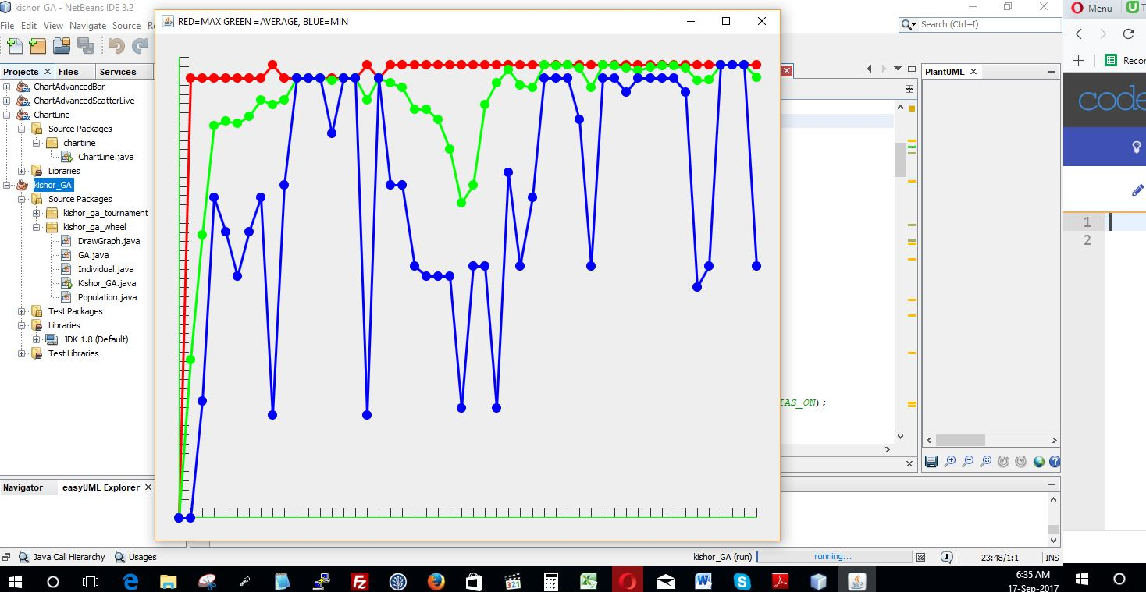

Reference Library  
1. <http://www.theprojectspot.com/tutorial-post/creating-a-genetic-algorithm-for-beginners/3>  
2. https://stackoverflow.com/questions/8693342/drawing-a-simple-line-graph-in-java

**Answer 2:**  
  
**Generation 0**

**Initial population**  
011110110  
011001011  
101101110  
000010101

**After discarding 2 least fit ones**

000010101  
011001011  
**reason no 1 and no 3 had 0 occurrence of 1 surrounding 0**  
  
**Single point cross over in 3 point**  
000|010101  
011|001011  
*000001011  
011010101*

**Mutated 1 bit in string 3 at 2nd position**000010101  
011001011  
010001011  
011010101 **Generation 1  
Initial population**  
000010101  
011001011  
010001011  
011010101

**After discarding 2 least fit ones**

000010101  
010001011  
**reason no 1 ,3,4 had 2 occurrence of 1 surrounding 0 , I choose first 1 &3**  
**Single point cross over in 5 point**  
00001|0101  
01000|1011  
*000011011  
010001011*

**Mutated 1 bit in string 2 at 4nd position**000010101  
010101011  
000011011  
010001011 **Generation 1  
Initial population**000010101  
010101011  
000011011  
010001011 **After discarding 2 least fit ones**

000010101  
010101011  
**reason no 1 , 4 had 2 occurrence of 1 surrounding 0 , I choose 1**  
**Single point cross over in 2 point**  
00|0010101  
01|0001011  
000001011  
010010101

**Mutated 1 bit in string 1 at 4nd position**000110101  
010001011  
000001011  
010010101